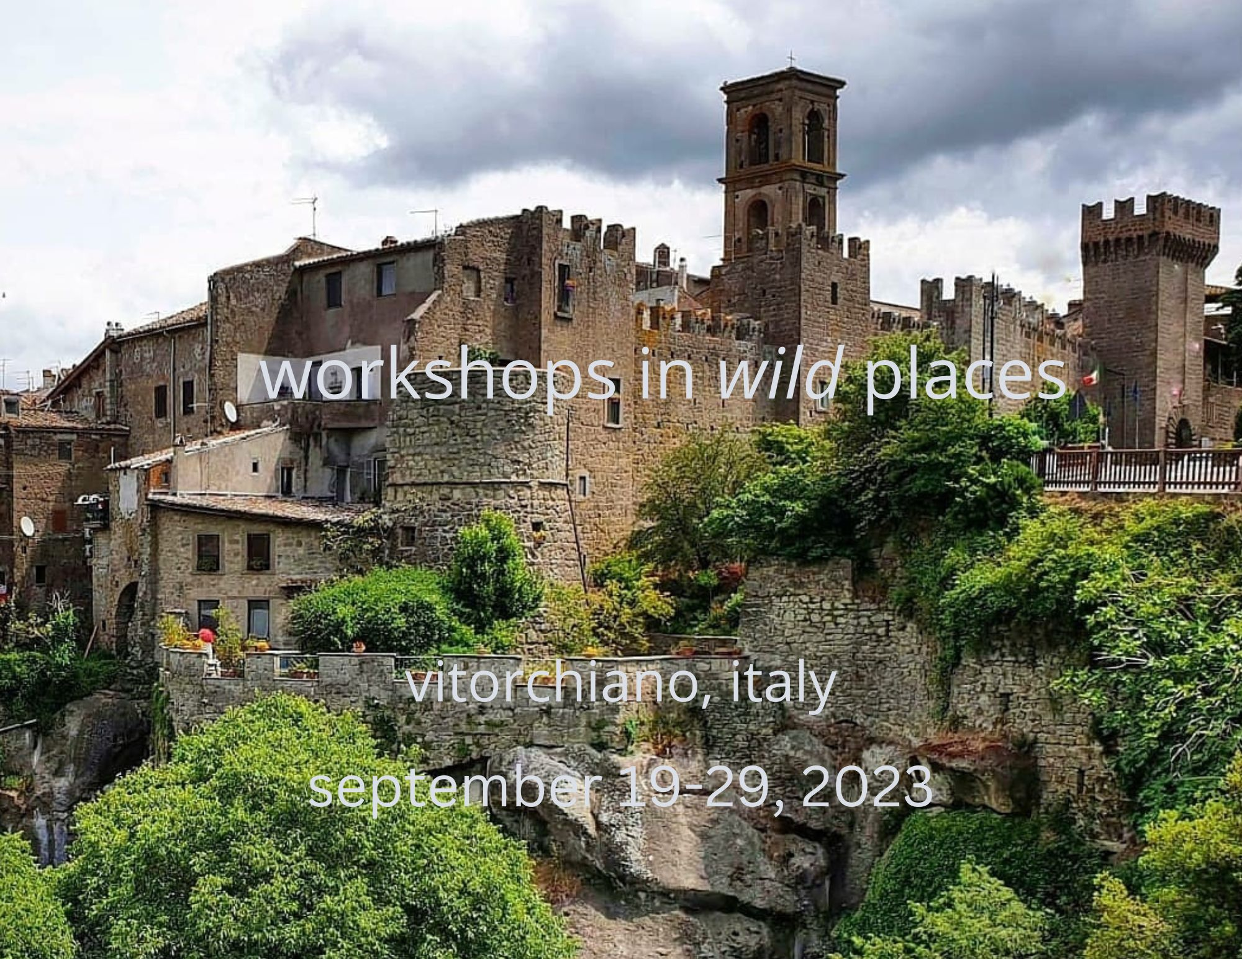

PAINTING THE SOUL OF PLACE IN ITALY

For 10 days we'll make our home in a medieval village just north of Rome and paint in the studio of American/Italian resident Linda Lappin, author of the book, The Soul of Place. This small Etruscan village is carved in grey flecked tufa, and perched on the edge of a dizzying gorge. Linda writes about her village, “This area of Italy called the Tuscia remains untouched by tourism. Here the local people still live by ancient trades: cutting wood, tending sheep, producing wine and olive oil, quarrying peperino, the volcanic stone which has provided the town’s livelihood for centuries. Beneath the quiet meadows blanketing the countryside lies a honeycomb of tombs extending for miles on end.(…) Under the Etruscan shade lies a realm of mystery and eerie legend. The Etruscan vision of the afterlife was one of richness and fulfillment. D.H. Lawrence who came to the Tuscia in search of spiritual renewal, believed he had discovered here a fount from which he might draw new strength.”
Linda will give us writing exercises to connect with the soul of place and we'll spend 2 days visiting nearby Etruscan sites, such as the ancient village of Orvieto, the 15th century garden of Bomarzo and the hot springs of Viterbo. We'll do walking meditations, and painting exercises to help us connect to the land and energy of place and spend 4 or 5 days painting in the studio.

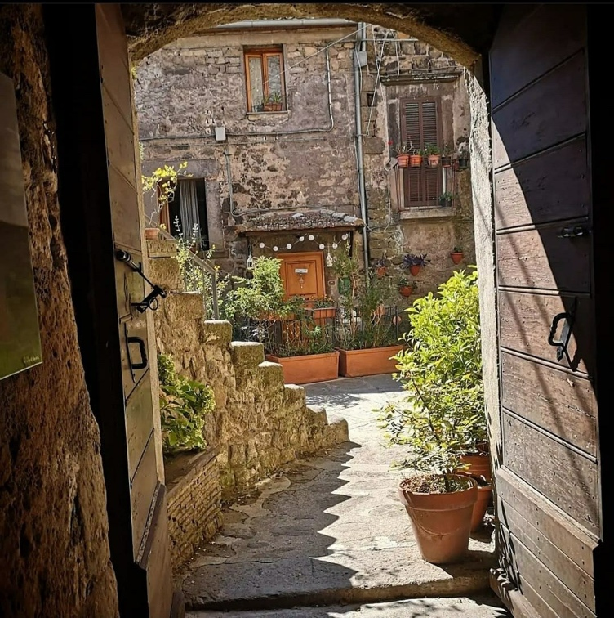

TOUR LEADER AND PAINTING INSTRUCTOR: Janice Mason Steeves will lead this painting workshop on deeply connecting with the land, providing inspiration to create abstract paintings. She is represented by galleries in Canada and the U.S., with work in public, corporate, and private collections in Canada and internationally. Janice teaches painting workshops internationally in her program, Workshops in Wild Places. She has been awarded artist residencies in Spain, Ireland, Sweden, Iceland and the U.S. Her websites are: janicemasonsteeves.com, workshopsinwildplaces.com
Linda Lappin the author of The Soul of Place: Ideas & Exercises for Conjuring the Genius Loci will lead a creative writing workshop on seeking inspiration, images, and stories from your immediate environment. She is the prize-winning author of four novels: The Etruscan (Wynkin deWorde, 2004), Katherine’s Wish (Wordcraft, 2008), dealing with the last five years of Katherine Mansfield’s life, Signatures in Stone: A Bomarzo Mystery (Pleasureboat Studio, 2013), and Loving Modigliani: The Afterlife of Jeanne Hébuterne (Serving House Books, 2020). Signatures in Stone was the overall winner of the Daphne DuMaurier prize for best mystery novel of 2013. She is also the author of The Soul of Place: Ideas and Exercises for Conjuring the Genius Loci, (Travelers Tales, 2015), which won a Nautilus Award in the category of creativity in 2015. A former Fulbright scholar to Italy, she has lived mainly in Rome for over thirty years. Her website is www.lindalappin.net

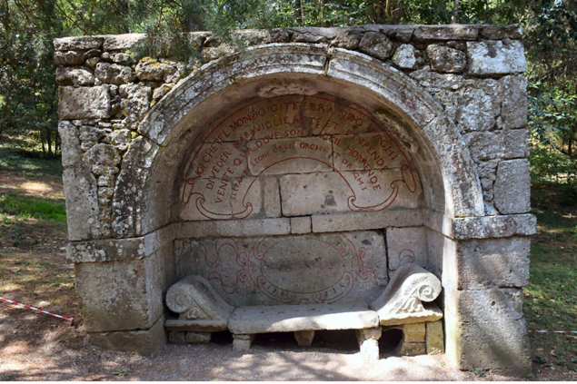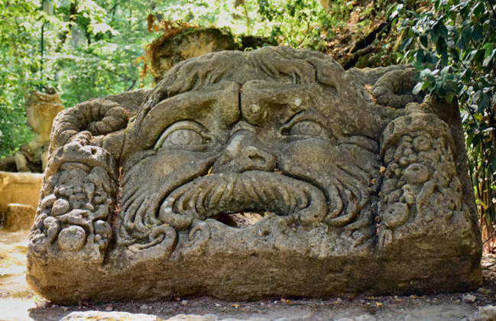

ITINERARY:

Tuesday September 19: Meet at Fiumicino airport in Rome
From Fiumicino travel by private coach about one hour to the village of Vitorchiano.

Wednesday, September 20
Settle in, tour of village
Welcome dinner

Thursday, September 21
Out trip: to be announced

Friday, September 22
Linda’s full day class in the studio

Saturday September 23
Full day in the studio.

Sunday, September 24 1/2 day Out trip: to be announced
PM Studio

Monday September 25
Full day-studio

Tuesday September 26
Full day-Studio

Wednesday, September 27
Day off: Explore the village, paint in the studio or take it easy

Thursday September 28
Final day in the studio
Closing ceremony in the evening
Final dinner

Friday September 29
Say goodbye to Vitorchiano
Transfer by private coach to Fiumicino airport in Rome. Fly home.

TOUR DETAILS

TOUR COST (Per person): $3450 CAD (approx. $2700US)

GROUP SIZE: Limited to 5 workshop participants

INCLUDED FEATURES:
Accommodation for 10 nights in single occupancy with ensuite at Casa Dante
Breakfast daily
Two dinners: First and last night
All taxes and gratuities and entrance fees
Return transfer from Fiumicino airport in Rome to Vitorchiano
Transportation by private coach for 2 days of local excursions: Bomarzo, Orvieto and Viterbo hot springs
Workshop with Janice Includes rental of studio space
One-day writing workshop with Linda Lappin

NOT INCLUDED:
Roundtrip Airfare from your home to join the tour
Beverages with meals
Art supplies: A Materials List will be provided
Items of a personal nature
Travel Insurance (highly recommended)
Additional arrangements required due to any emergency or other situation
Any item not mentioned in “tour cost includes” above

PAYMENT DETAILS:
A non-refundable deposit of C$500 per person is required to reserve a space on this tour. A second deposit of C$2000 is due six months prior to departure (March 20, 2023). Final payment is due 90 days prior to departure on June 21, 2023. ($950)

CONTACT JANICE TO REGISTER:
janicemasonsteeves@gmail.com

